MATCHED GIVING

Thank you for going further this October by participating in Oceans to Outback and raising funds to help the Royal Flying Doctor Service reach more Australians with life-saving care!

The biggest way you can boost your fundraising efforts this October and double your impact, is for your workplace to match the funds that you and your colleagues raise.

The following emails are designed to encourage key stakeholders in your workplace to get behind Oceans to Outback and super-charge your efforts by matching the funds you raise. These are intended as guides only, so please feel free to adapt the emails to suit your workplace.

Please remember, we have plenty of workplace specific resources to assist you and your team on your fundraising journey. They can be found here: https://www.oceanstooutback.org.au/workplaces

If you have any questions or need some further advice on matched giving, please drop me an email at supporters@oceanstooutback.org.au or click here to arrange a call back.

I’ll leave you with this thought... if you don’t ask, then the answer is always no. Let’s ask the important question and help RFDS provide the finest standard of care to every Australian who needs them.

Thanks so much for your support and good luck!

Kind regards

Lauren Lynagh

Oceans to Outback Fundraising Manager
Email No. | Email 1 – Matched Giving
Notes | Send this email to the staff member who oversees charity activities / donations  (Your CEO / Executive team / HR / Corporate Social Responsibility etc)
Send date | As soon as you have signed up your Organisation to Oceans to Outback
Sender | Organisation Captain or a passionate member of your workplace team!

Email 1 – Matched Giving
*Wording highlighted in yellow within the templates requires you to add information about your Workplace

SUBJECT LINE: Boost <organisations name>’s efforts in Oceans to Outback!

Dear <Name/s>,

This year, I am leading a team of <organisations name> employees as we take on Oceans to Outback for the Royal Flying Doctor Service. This virtual event challenges us to walk, run or ride a significant distance during the month of October while raising funds to help RFDS deliver essential primary health care to every Australian, no matter where they live.

I am writing to you today to ask <organisations name> to match the funds we raise.

I’m personally taking on the challenge this year because <insert why you have signed up to Oceans to Outback> and have chosen to <walk / run / ride> <insert KM goal> throughout October. Our team’s collective goal is <insert team KM goal>, an ambitious target, but we’re excited to give it our best shot!

One Australian needs the Flying Doctor every two minutes. Whether it’s a life-threatening injury, an inter-hospital transfer, to see a GP, dentist or mental health clinician, for 96 years, the Royal Flying Doctor Service has provided a crucial mantle of safety for people living in remote, rural and regional areas.

Access to prompt, reliable healthcare is something that many of us take for granted. By supporting Oceans to Outback we can ensure the Flying Doctor is able to provide the finest standard of care to every Australian who needs them.

Please watch this video if you have a moment:

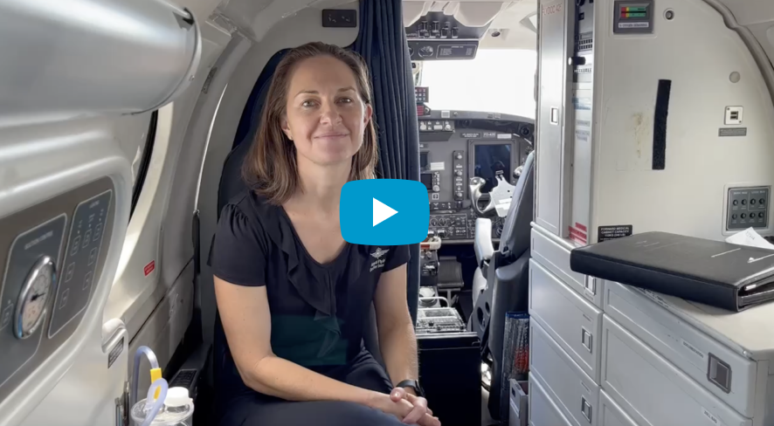

Our participation in Oceans to Outback will bring great benefits to <organisations name>:
- Promote health and wellbeing:
Physical activity, such as walking, running, or cycling, is a proven way to improve both physical and mental health, so participation is a great way to support our team’s health and wellbeing.

- Boost motivation and morale:
Bring our colleagues together around a shared purpose of wellbeing and giving back to the community, inspire friendly competition and have some fun along the way!

- Supports organisational culture and reputation:
Workplaces with a culture of giving and supporting charitable causes have been shown to enjoy greater employee engagement, retention, productivity, reputation and social impact.

All team members will be raising funds for RFDS during the challenge. For every $1 we raise, I am asking < organisations name> to match it with $1. So then $50 becomes $100!

I’d love to talk more about how < organisations name> can support this amazing initiative so I’ll give you a call in the next couple of days to follow up.

Thanks for considering this and helping RFDS travel further, respond quicker, and deliver essential primary health care to every Australian — no matter where they live.
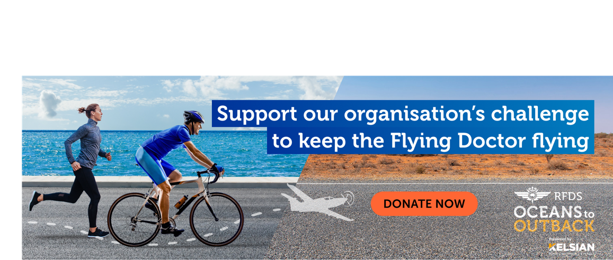
Kind regards
<Signature>

Email No. | Email 2 – Follow up
Notes | Send this to the person/people you sent your first matched giving email to
Send date | One week after the first email (if you haven’t heard back)
Sender | Organisation Captain or a passionate member of your workplace team!

Email 2 – Follow up
*Wording highlighted in yellow within the templates requires you to add information about your workplace

SUBJECT LINE: We need your help to double our impact!

Dear <Name/s>,

Oceans to Outback is just around the corner and we would greatly appreciate < organisations name>’s support through matching the funds we raise throughout the challenge.

Matched giving has been shown to triple the amount team members raise and will be an invaluable way to increase < organisations name>’s impact whilst demonstrating your support internally and to the wider community.

One Australian needs the Flying Doctor every two minutes. It’s only through the support of fundraisers and donors like us that RFDS can deliver life-saving care to every Australian who needs them, no matter where they live.

If you would like further information about matched giving or Oceans to Outback, please don’t hesitate to give me a call on <insert your contact phone> or you can talk directly to Lauren Lynagh at the Royal Flying Doctor Service via an email to supporters@oceanstooutback.org.au or by clicking here to arrange a call back.

Thank you again for your consideration, I hope < organisations name> can support this fantastic initiative.
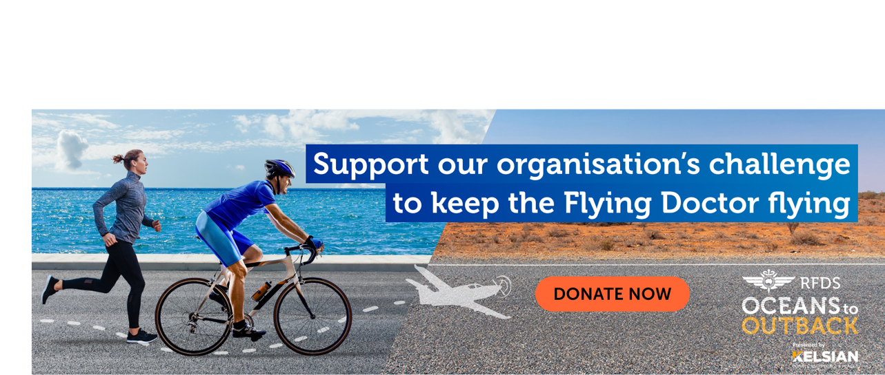
Kind regards
<Signature>

